BGP Routing

1. **Why BGP is used?**

BGP gives more control over route selection and neighbor's route selection. That's one of the major reasons BGP is The Routing Protocol for the Internet.

1. **Objectives**

* BGP routing
* Extended and Standard ACL
* DHCP across the routers
* SSH in all routers

1. **Network Design**

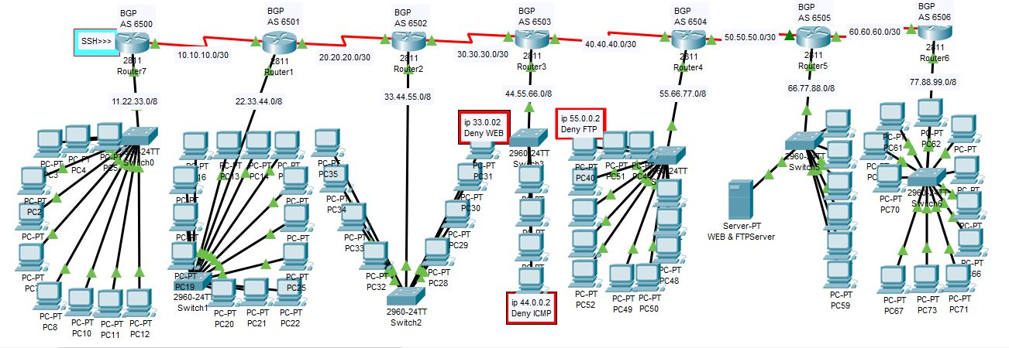

1. **BGP Configuration**

#int loopback 0

#ip add 1.1.1.1 255.255.255.255

#router bgp 6500

#neighbor 10.10.10.2 remote-as 6501

#network 1.1.1.1 mask 255.255.255.255

#network 10.10.10.0 mask 255.255.255.252

**DHCP Configuration**

#ip dhcp pool A

#network 11.22.33.0 255.0.0.0

#dns-server 8.8.8.8

**SSH configuration**

#hostname R1

#enable password 111

#username ELO password 222

##ip domain-name google.com

#crypto key generate rsa

#1024

#line vty 0 4

#Password 333

#login

#login local

#transport input ssh

PC5> ssh –l ELO 11.22.33.1

Password: 222

R1>

**ACL Config**

#access-list 100 deny icmp host 44.0.0.2 host 66.0.0.2

#access-list 100 deny tcp host 55.0.0.2 eq ftp

#permit ip any any

#int fa 0/0

Access-group 100 out

1. Testing

